11

Look at the circuit below. tick one box () to show if the bulb is lit or not.

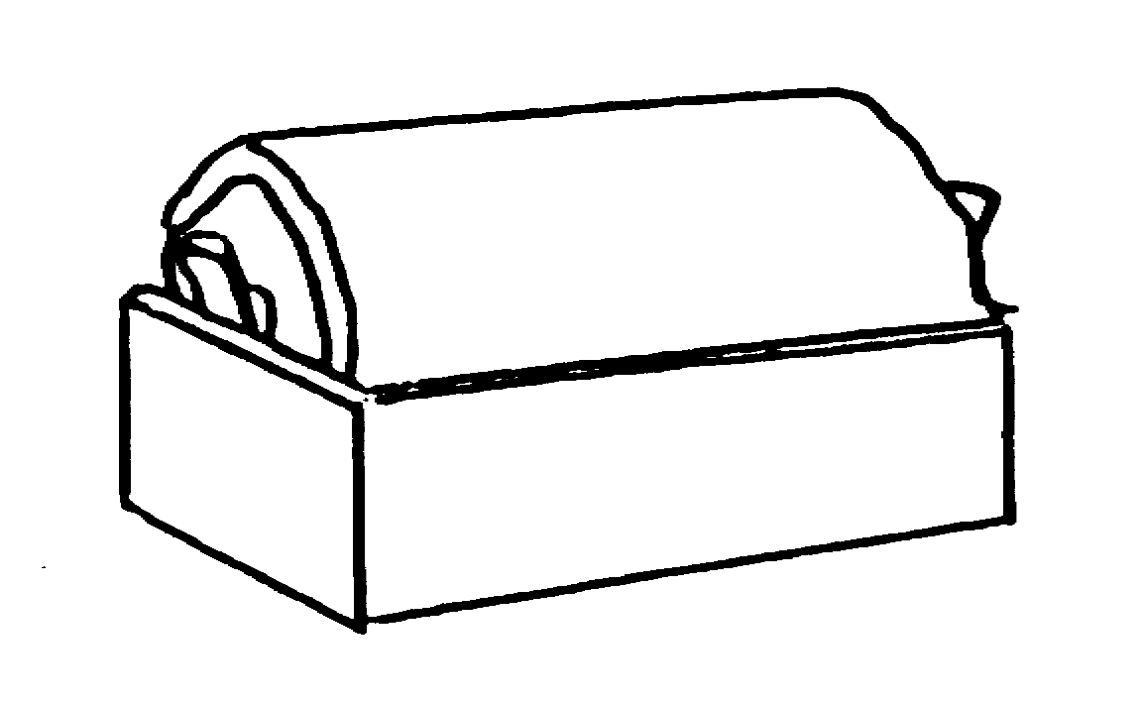
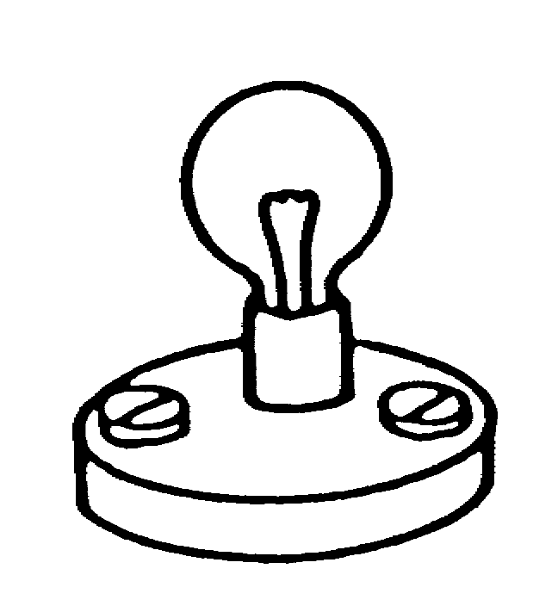

.

not lit
lit

Explain your answer:

__________________________________________________________

__________________________________________________________

__________________________________________________________

__________________________________________________________

